5. Assessment of MAX30102 Biometric Sensor Precision
5.1. Enhancements in Accuracy and Architectural Effectiveness
The dependability of optical photoplethysmography (PPG) sensors, such as the MAX30102, is significantly affected by digital timing jitter and environmental noise. In the early iterations of IoT health devices, the sequential processing of sensor data and Wi-Fi transmission frequently results in lost samples and inconsistent vital values. The proposed design enhanced the clinical accuracy of the MAX30102 by isolating the processing logic within a FreeRTOS multitasking environment [1]. By allocating the biometric sampling duty exclusively to Core 1 of the ESP32’s Xtensa processor, the system attains a remarkably constant 400Hz polling rate across a Fast Mode Inter-Integrated Circuit (I2C) bus, unaffected by background network interruptions. Additionally, a stringent digital thresholding mechanism was implemented (IR < 15000). This guarantees that the measurement arrays are promptly cleared upon finger removal, hence reducing the computation of extraneous data and averting false positives. A real-time moving average filter with a temporal window of N = 5 was employed to smooth the resultant waveforms and reduce high-frequency motion artifacts in the heart rate and blood oxygen arrays.

5.2. Mathematical Basis for SpO2 Calculation
The MAX30102 measures blood oxygen saturation (SpO2) by emitting two distinct wavelengths of light: Red $660 nm) and Infrared (880nm). Oxygenated hemoglobin (HbO2) exhibits greater absorption of infrared light, whereas deoxygenated hemoglobin (Hb) demonstrates increased absorption of red light. The sensor's integrated Analog-to-Digital Converter (ADC) records these reflections, consisting of a direct current (DC) component (indicative of static tissue and venous blood) and an alternating current (AC) component (indicative of pulsatile arterial blood) [2].

The fundamental algorithm isolates the pulsatile signal to compute the "Ratio of Ratios" (R), mathematically defined as:

R = $\frac{(\frac{{AC}_{red}}{{DC}_{red}})}{(\frac{{AC}_{ir}}{{DC}_{ir}})}$
Upon dynamic computation of R from the localized peak and trough data within the sampling buffer, the empirical blood oxygen percentage is obtained utilizing the manufacturer's standard linear calibration formula [2]:

SpO₂ = 104 - 17R

The moving average filter utilized to stabilize the final heart rate (HR) and SpO2 outputs is determined by the discrete convolution equation:
$$\overline{x_{k}}= \frac{1}{N} \sum_{i=0}^{N-1}{x_{k-i}}$$
Here, $\overline{x_{k}}$ denotes the smoothed output, x signifies the raw computed metric, and N indicates the size of the smoothing buffer.

5.3. Prospective Areas for Optimization
The existing moving average filter offers fundamental stability, although the system's robustness against intense motion artifacts might be enhanced. Subsequent software versions ought to evolve from a rudimentary averaging method to an Infinite Impulse Response (IIR) or Butterworth low-pass filter to effectively diminish frequency noise beyond the human physiological range 0.5 Hz to 4.0 Hz [3]. The MAX30102, from a hardware standpoint, utilizes reflecting optics, rendering it susceptible to ambient light saturation, such as intense sunlight or fluorescent flashing. Incorporating a 3D-printed optical shield or an acrylic baffle over the sensor module would limit the entry of ambient light. Moreover, varying finger pressure modifies capillary density, distorting the AC signal. The implementation of a mechanical spring-loaded clip mechanism would normalize the pressure exerted on the diode array, hence enhancing the repeatability and clinical validity of the localized measurements.

5.4. Schematic of MAX30102 Integration Circuit
This conceptual diagram depicts the localized physical integration of the central edge processor with the biometric module. It is advisable to use standard 4.7kΩ pull-up resistors on the I2C lines to preserve the integrity of high-frequency square waves at 400 kHz.
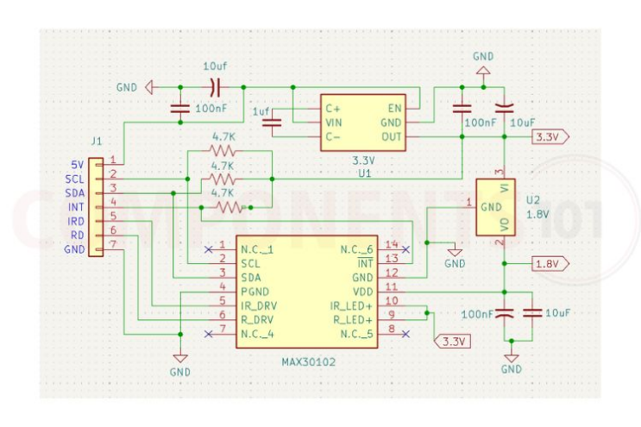

Fig: Max30102 sensor inner circuit schematic of inner structure. [4]
Reference:
[1] A. K. Katkoori, D. B. Prakash, R. Kumar M, A. S. Reddy, and G. P. Kumar, "FreeRTOS and IoT Based Smart Physiological Parameter Monitoring System," in 2026 IEEE International Conference on Intelligent Systems, Smart and Green Technologies (ICISSGT), 2026, pp. 1-5. [Online]. Available: https://api.semanticscholar.org/CorpusID:287965183
[2] Analog Devices, "MAX30102: High-Sensitivity Pulse Oximeter and Heart-Rate Sensor for Wearable Health," Data Sheet, Rev. 1, Oct. 2018. [Online]. Available: https://www.analog.com/media/en/technical-documentation/data-sheets/max30102.pdf
[3] IEEE, "Motion Artifact Reduction in Photoplethysmography for Reliable Signal Selection," in Proc. IEEE Eng. Med. Biol. Soc. (EMBC), 2021. [Online]. Available: https://www.paperhost.org/proceedings/embs/EMBC21/files/1756.pdf
[4] “MAX30102 sensor oximeter and heart rate,” Components101. https://components101.com/sensors/max30102-sensor-oximeter-and-heart-rate-pinout-datasheet

